Laboratory Practice II Cloud Computing (A-4)

**Problem Statement:- Design and develop custom Application (Mini Project) using Salesforce Cloud.**

**Application: Order Details App**

**Step 1:** Log into Salesforce Developer account.

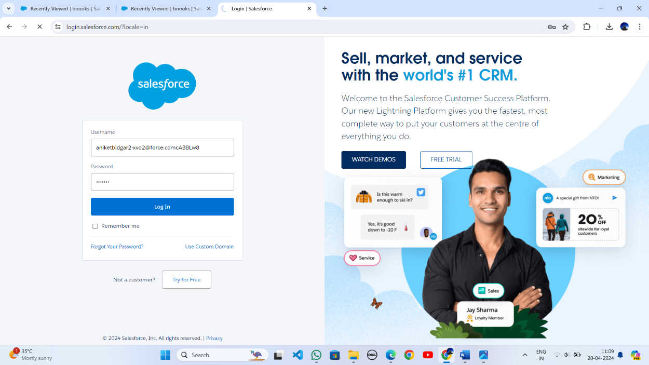

**Step 2:** Open Salesforce Lightning platform and click on Object Manager =>Create => Custom Object.

